St Paul’s Catholic Primary School Alnwick

‘Growing in God’s Love to be the Best We Can Be’

Evidencing the impact of the Primary PE and sports premium.
Academic Year: 2022/2023

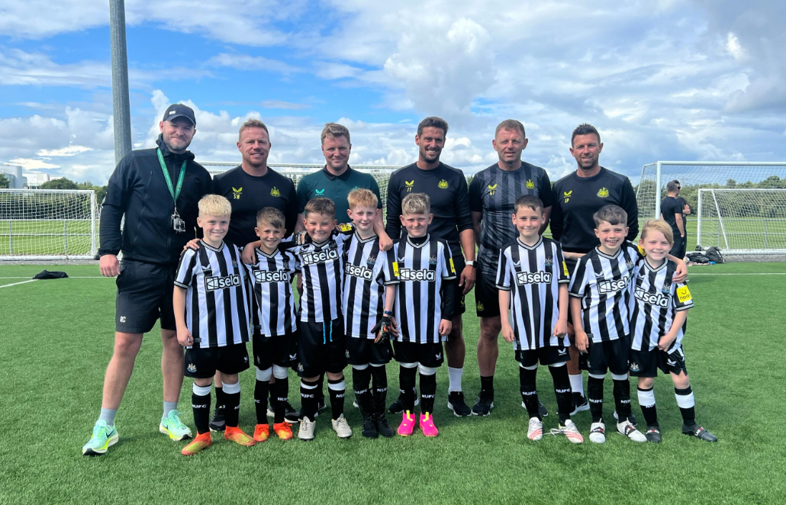
Funding Breakdown

Total amount carried over from 2021/22 | £ 0
Total amount allocated for 2021/22 | £ 17520
How much (if any) do you intend to carry over from this total fund into 2022/23? | £ 0.00
Total amount allocated for 2022/23 | £ 17460
Total amount of funding for 2021/22. To be spent and reported on by 31st July 2023. | £ 17460

Swimming Data

Percentage of your current Year 6 cohort swim competently, confidently and proficiently over a distance of at least 25 metres. | 75%
Percentage of your current Year 6 cohort use a range of strokes effectively. | 68%
What percentage of your current Year 6 cohort perform safe self-rescue in different water-based situations? | 64%
Schools can choose to use the Primary PE and sport premium to provide additional provision for swimming but this must be for activity over and above the national curriculum requirements. Have you used it in this way? | No

Action Plan and Budget Tracking

Academic Year: 2022/23 | Total fund allocated: £17460 | Date Updated: July 2023
Key indicator 1: The engagement of all pupils in regular physical activity |  |  |  | Percentage of total allocation:
 |  |  |  | 75%
Intent | Implementation | Funding Allocation | Impact | Next Steps
- Develop multiple opportunities for ALL children to be physically active and improve their personal fitness levels to achieve their sporting personal bests.  - Greater engagement in physical activity amongst all children, during and after school. | - All classes from R-Yr6 participate in the daily mile. Pupils encouraged to monitor times in KS2 to improve their personal bests.  - Sports Club’s offered afterschool. Dance, Football, gymnastics and multi skills.  - Specialist support for dance, gymnastics and cricket in addition to Newcastle Foundation offer. | £13,000allocated but £13,035 spent | - Increased stamina and skill due to daily coaching and running.  - Engagement in gymnastics and dance improved balance and coordination.  - Newcastle Foundation and St Paul’s Staff offered extra-curricular sporting activities after school.  - Increased subsidised holiday sporting provision | - Continue to encourage participation in the daily mile across school.  - Continue to offer a wide range of sporting extracurricular activities to ensure all pupils are provided with an option of a sporting activity that they enjoy.  - Introduce sports leaders across school to implement and observe breaktime, physical activities and pupil uptake.
Key indicator 2: The profile of PE being raised across the school as a tool for whole school improvement |  |  |  | Percentage of total allocation:
 |  |  |  | 6%
Intent | Implementation | Funding Allocation | Impact | Next Steps
- Provide a range of competitive and non-competitive sporting activities throughout the year between year groups and with other schools.  - Newcastle Foundation + specialist gymnastics and dance teaching  - Increase the amount of competitive sport activities within BBCET schools.  - Promote sport clubs and sporting success through school communication and social media. | - Opportunities to participate in competition with other schools within the BBCET.  - Opportunities to play competitive football against schools from all over the North East in a professional training facility.  - Opportunities to participate in non-competitive sport festivals.  - Opportunities to receive sports coaching at sporting venues including Newcastle United training ground, Alnwick Cricket Club and Newcastle United football stadium.  - Professional journalist for BBCET to report in media. | £1,000 | - Sporting achievements were celebrated in various forms including local press.  - Raised profile of school through competitive activities.  - Opportunities for children to play in professional facilities, meet famous sports people.  - Increased confidence. | - Continue to celebrate sporting success both in school and outside school.  - Increase collaboration with partnership schools in local area to participate in sporting events.

Key indicator 3: Increased confidence, knowledge and skills of all staff in teaching PE and sport |  |  |  | Percentage of total allocation:
 |  |  |  | 4% for additional spend
Intent | Implementation | Funding Allocation | Impact | Next Steps
- Focused teaching and development of key skills within PE lessons, led by a specialist coach from Newcastle United Foundation. Teachers to observe the teaching of these skills.  - CPD sessions for staff led by Newcastle United Foundation.  - Teaching staff to lead clubs building upon their CPD sessions. | - Development of staff skills set within a PE lesson delivered by Newcastle Foundation. School staff to observe and participate in lessons.  - Staff to use skills set to deliver sports clubs within school.  - Employment of a specialist gymnastics, dance and cricket coach.  - Teachers increase confidence to lead after school clubs. | SLA for Newcastle Foundation and additional cost of £700 for specialist coaches. | - Increased knowledge and understanding of how to teach fundamental skills.  - Staff delivered after school clubs, enabling a greater use of agility and coordination engaging both boy and girls in the activity. | - Staff to evaluate their expertise developed in their performance management meetings.  - Teaching staff to be encouraged to participate in age appropriate competitions across the school’s partnerships.
Key indicator 4: Broader experience of a range of sports and activities offered to all pupils |  |  |  | Percentage of total allocation:
 |  |  |  | 10%
Intent | Implementation | Funding Allocation | Impact | Next Steps
- Greater variety of sporting activities and locations experienced across all key stages in school.  - Wider range of adventurous activities offered.  - All children in KS2 to have access to age appropriate, competitive sports.  - Introduce cycling to the wider PE curriculum. | - Further opportunities provided for age appropriate adventurous activities including coasteering and axe-throwing.  - Newcastle Foundation deliver two days of PE sessions.  - Bike ability offered to all pupils.  - Small number of cycles and scooters purchased. | £1800 | - Pupils experience the skill of axe throwing on the school site, enabling them to use the many skills they have developed through the PE curriculum.  - Experienced coaches from Newcastle Foundation delivered a highly skilled based PE curriculum across school.  - Specialists delivered gymnastics, dance and cricket sessions.  - Pupils attended a coasteering experience led by specialists.  - Pupils from Rec to Y6 participated in a bike ability programme. | - Continue to increase the range of sporting opportunities in school.  - Continue to develop our offering of Bike Ability to KS1 and Early Years.  - Encourage children to use their bike’s as a method of transport to school.  - Continue to develop our offering of adventurous activities in school.  - Extend resources to offer cycling as class lesson and after school activity using installed cycle track.

Key indicator 5: Increased participation in competitive sport |  |  |  | Percentage of total allocation:
 |  |  |  | 10%
Intent | Implementation | Funding Allocation | Impact | Next Steps
- Promote pupil activity through involvement in competitive age appropriate competitions with peers and other partnership schools.  - Embed our RESPECT curriculum values of Resilience, Empathy, Self-aware, Positive, Excellence, Communication and Teamwork in a sporting arena. | - Transport to schools and venues within the North East to participate in sporting activities  - Participation in Sporting Festivals and competitions. | £1840 – spend £1790 | - Pupils increased levels of resilience and confidence whilst participating in age appropriate competitive sport.  - Opportunities to mix with children from different localities within the North East developing their awareness of diversity.  - Opportunities to visit stadiums, resource facilities used by professional sports people.  - Opportunities to use professional sporting facilities.  - Opportunities to meet ‘famous’ sports people | - Continue to participate in age appropriate competitive sporting competitions with peer and other partnership schools.  - Increased participation in sporting events within BBCET and Alnwick Partnership.
- TOTAL ALLOCATION: £17640 TOTAL SPEND: £18,325

Signed off by
Head Teacher: | Mrs Lomax
Date: | 21/7/23
Subject Leader: | Mr Cook (Miss Hellawell – maternity leave)
Date: | 21/7/23
Governor: | Mrs Sinclair
Date: | 21/7/23

