**St. Paul’s Catholic Primary School**



**Growing in God’s Love to Be the Best We Can Be**

REMOTE LEARNING

Information for Parents

(last updated December 2021)

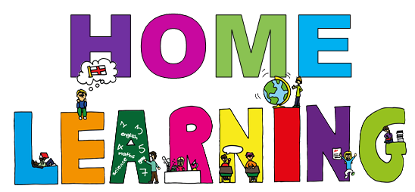

At St. Paul’s it is our mission to ensure everyone in our school family *‘Grow in God’s Love to Be the Best they can Be.’*

Our core values are:

Have FAITH

Show RESPECT

Develop RESILIENCE

and Achieve HAPPINESS

All aspects of school life encourage us to strive to fulfil our full potential and we are very proud of our strong home-school-parish partnership. Working together we promote a love of learning and life following Jesus as our example, ensuring that discovering, revealing and sharing in Jesus underpins everything. During COVID-19 Summer lockdown our community lived out the gospel values and supported each other. Now we have entered another period of lockdown we continue to work together, truly dedicated to supporting each other and developing all to ‘be the best they can be.’

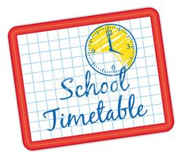

**Will my child be taught broadly the same curriculum as they would if they were in school?**

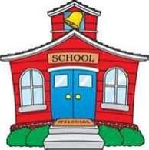

We teach the same curriculum remotely as we do in school wherever possible and appropriate. However, we have needed to make some adaptations in some subjects. For example, parents will not have access to the same resources we would have in school for some practical subjects such as PE or Science therefore we will adapt lesson planning to reflect this. In such cases, the teacher may post a video demonstration or add links to the Google platform so pupils can view and observe  suitable alternative material. Additionally, subjects such as music and physical education will be different for obvious reasons, and teachers will suggest alternative ways in which pupils can embark on relevant activities in these areas.

**How long can I expect work set by the school to take my child each day?**



We expect that remote education (including remote teaching and independent work) will take pupils broadly the following number of hours each day:

Reception and KS1 – three hours per day

KS2 – four hours per day

Little Lambs and Nursery – approx. one and a half hours per day

Please note, this does not mean ‘live’ or direct taught sessions, it simply refers to the expected time that pupils should spend engaged in learning activities.

**ACCESSING REMOTE EDUCATION**

**How will my child access any online remote education you are providing?**



All children in Little Lambs, Nursery and Reception will access daily learning experiences via Class Dojo. Daily tasks and links to lessons will be shared by the class teacher. Parents are encouraged to upload photos and work on their child’s Dojo portfolio. Reception children can access learning on the Google Classroom as directed by the class teacher.

Children in Reception class also have user names and passwords for some educational apps which have been selected to complement our offer.

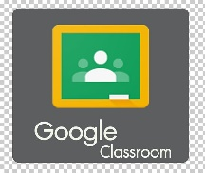

All children in Years 1 – 6 have a Google Classroom login which gives them access to our school platform.

Children also have user names and passwords for some educational apps which have been selected to complement our offer.

**If my child does not have digital or online access at home, how will you support them to access remote education?**



We recognise that some pupils may not have suitable online access at home. We take the following approaches to support those pupils to access remote education:

* We will provide temporary loan of a school device. An acceptable use agreement must be signed before loaning the device. A digital form will be sent to your mobile phone and email or a paper copy is available on request.

For internet connectivity, please contact the school office as we may be able to request mobile data increases for pupils in families who:

* do not have fixed broadband at home
* cannot afford additional data for their devices
* are experiencing disruption to their face-to-face education

Pupils whose parents with access to a mobile phone on one of the following networks might be able to benefit:  Three , Smarty,  Virgin Mobile  EE  Tesco Mobile  Sky Mobile  O2.

In addition to the above:

* We will offer printed work books to be collected from school.
* We will send tasks via Class Dojo to parents.
* We will accept work submitted via Google Classroom or photographs uploaded to child’s Class Dojo portfolio.

**How will my child be taught remotely?**

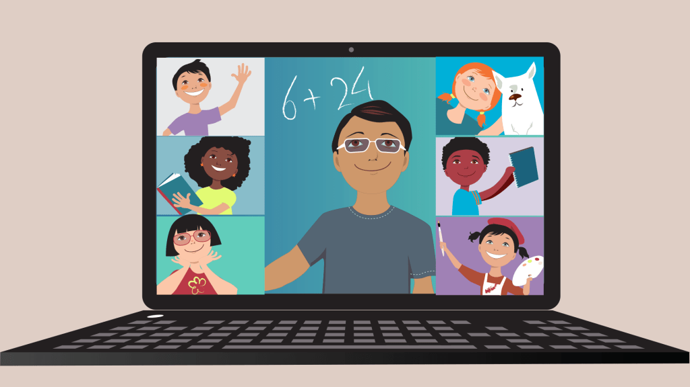

We use a combination of the following approaches to teach pupils remotely:

In KS1 and KS2 there will be a combination of:

* Live teaching sessions (feedback/misconceptions/ guided reading/ spelling/ well being) through the Google classroom.
* Recorded teaching (e.g. Oak National Academy lessons, video/audio recordings made by teachers)
* Log in details to various school subscriptions (Lexia, TTRS, Numbots, Maths Whizz, Letter Join, Spelling Frame, Oxford Owl)
* CPG Maths and English packs purchased as supplement or in case of internet failure
* reading books for all / class novel in KS2
* year group links to commercially available websites supporting the teaching of specific subjects or areas, including video clips or sequences on school website
* Additional challenges through some project work – Commando Joe’s / Well Being Wednesday

In EYFS there will be a combination of:

* recorded teaching (e.g. video/audio recordings made by teachers, Oak Academy lessons
* Live teaching sessions (reading, phonics, mental maths, well being)
* Google Classroom activities
* Log in details to various school subscriptions (Numbots, Letter Join, Oxford Owl)
* Reading books children have at home
* Reception year group folder on website with links to commercially available websites supporting the teaching of specific subjects or areas, including video clips or sequences.
* CPG Maths and English pack purchased as supplement or in case of internet failure
* Additional challenges through some project work – Commando Joe’s

**ENGAGEMENT AND FEEDBACK**

**What are your expectations for my child’s engagement and the support that we as parents and carers should provide at home?**

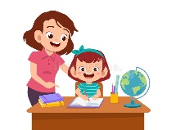

* We would ask that pupils complete school work every day for a minimum of 3 hours or 4 hours in KS2.
* We would ask that parents make best endeavors to return work through online platforms 360 or Class Dojo portfolio.
* Parents should email [admin@stpaulsalnwick.co.uk](mailto:admin@stpaulsalnwick.co.uk) or ring school to let staff know of any barriers to completing work.
* Children are asked to engage in at least two Google Meets per week with their class teacher.

***Here are some useful tips……***

* *1. Help your child to establish a good routine. Maintain sensible bedtimes, mealtimes etc.*
* *2. Take an interest in what your child is doing, perhaps read the daily online instructions together.*
* *3. If your child gets stuck, don’t worry! Put a message into the Google classroom or Class Dojo if you can’t help.*
* *4. Monitor online activity and don’t let your child spend too much time online. Encourage breaks and exercise etc, join in the games if you can. Keep encouraging your child in all they do.*
* *6. Give yourself some time too! Step away and let your child get on with some things on their own.*
* *7. If you have any queries or concerns, email the school office or put a message into your child’s Google classroom or Class Dojo and the teacher will get back to you. (please try to message during school hours and understand that responses may not be instant)*
* ***And some tips for pupils…….***
* *1. Try and get into a routine, set yourself a time each day when you get on with your home learning pack.*
* *2. Try to log in to your online classroom and stay in touch with your classmates. Do this between 8:30am and 3pm. If you don’t understand the teacher’s instructions, send a message into your classroom. Your teacher or even your classmates will respond. Try to submit work if you’ve been asked to. The more contact through Google classroom, the better, as your teachers really want to stay in touch with you!*
* *3. Take regular breaks from your computer/phone/tablet screen—do some reading.*
* *4. Try to take some daily exercise.*
* *5. Be respectful…...behave well, speak to your parents, brothers, sisters etc. in the same way you’d speak to your teachers.*
* *6. Don’t worry if you don’t manage to complete all tasks, just do your best and let your teacher know if you’ve struggled.*
* *7. Try to do some fun things too, cooking, building dens, art, play some games—If you can, get some fresh air…..Have fun!*
* *8. Stay safe online…… if anything troubles you, tell an adult straight away.*

**How will you check whether my child is engaging with their work and how will I be informed if there are concerns?**



* School will keep records of pupils accessing learning via Class Dojo portfolio and the virtual Google 360 classroom.
* School will contact parents if there is no activity via Class Dojo or on Google Classroom to offer further help and support.
* As well as ensuring learning is continuing for children, we must also maintain our duty of care. In normal school time, if a child was absent, and school had received no notification giving a reason why, we would seek to contact parents to find out the reason for absence. Regarding remote learning, we apply the same principle that where we notice a child has not logged in, we will seek to contact parents and carers.  Therefore, if your child is unwell and not fit to carry out home learning, you must let us know.
* We now have a responsibility to inform the Department for Education if children are not able to access remote learning due to Covid related reasons. Below is our stepped approach to checking levels of engagement.

|  |  |
| --- | --- |
| **Scenario** | **Action** |
| No evidence of child logging into Google Classroom in a 24-hour period or no evidence of work completed on Class Dojo. | Welfare call in the first instance to check on health and wellbeing as well as identifying any reason for not engaging. This could result in:   * Illness reported to teacher * Reminder of importance of logging in and accessing learning – agreement reached to ensure frequent engagement. * Technical issues identified and support provided. |
| Still insufficient evidence of child logging into learning, | Class teacher to call home and speak directly with parents and, where appropriate, the child too. Stress importance of the situation and agree way forward. Additional support may be offered, i.e. alternative learning activities, agreed online one-to-one tutorials etc. |
| Ongoing lack of engagement despite repeated contact. Offers of support not taken up or agreed actions not implemented. | HT to contact parents through home visit if necessary and share concerns.  School will seek to escalate this and engage additional support through children’s services. |

**How will you assess my child’s work and progress?**



Feedback can take many forms and may not always mean extensive written comments for individual children.

For example, whole-class feedback or quizzes marked automatically via digital platforms are also valid and effective methods, amongst many others.

Our approach to feeding back on pupil work is as follows:

* Pupils will receive live feedback during live Google Meet sessions.
* Pupils will receive feedback via the apps school uses such as Lexia, Maths Whizz, Numbots, TTRS. Teachers will monitor usage and progress.
* Pupils will receive comments on submitted work via Class Dojo or Google Classroom at least 3 times per week. This may be written feedback or a recorded message.

**ADDITIONAL SUPPORT FOR PUPILS WITH SPECIFIC NEEDS**

**How will you work with me to help my child who needs additional support from adults at home to access remote education?**

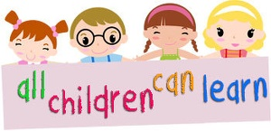

We recognise that some pupils, for example some pupils with special educational needs and disabilities (SEND), may not be able to access remote education without support from adults at home. We acknowledge the difficulties this may place on families, and we will work with parents and carers to support those pupils in the following ways:

* We will provide adapted lesson resources.
* Our SENDCO, Mr Chapman, will liaise with and support families if required.

**REMOTE EDUCATION FOR SELF-ISOLATING PUPILS**



Where individual pupils need to self-isolate but the majority of their peer group remains in school, how remote education is provided will likely differ slightly from the approach for whole groups. This is due to the challenges of teaching pupils both at home and in school.

**If my child is not in school because they are self-isolating, how will their remote education differ from the approaches described above?**

* Pupils will be expected to log onto the Google Classroom to access lessons unless school are informed that they are ill and not well enough to engage.
* Home learning is now compulsory as determined by the government. Please understand that whilst your child is at home isolating, their peers are at school will be continuing with their learning. If your child does not keep up with this, they will inevitably fall behind. This illustrates the importance of engaging with home learning.
* Home learning will be set the next working day after the period of self-isolation has been confirmed. It is intended that all learning tasks set will be based on what your child’s peers are covering in school. Please note that the teacher will not be on hand to provide feedback as swiftly as if we were in a full lockdown situation as he/she will be occupied teaching the class throughout the day.
* Teachers won’t routinely set home learning activities for pupils awaiting test results as they are usually able to return to school within a day.
* In EYFS activities and tasks will be shared via Class Dojo and some will be set on the Google Classroom.
* In the event of the majority of the class contracting COVID at the same time live lessons may be introduced so those at home and school have access to the teacher.

We will review this provision at timely intervals based on our own evaluations, information from parental surveys or at any point when government guidance dictates that a change in approach might be necessary.